Print Nightmare
TTP
- Initial access
T1078 – Valid Accounts
Domain user to reach RPC from print spooler service
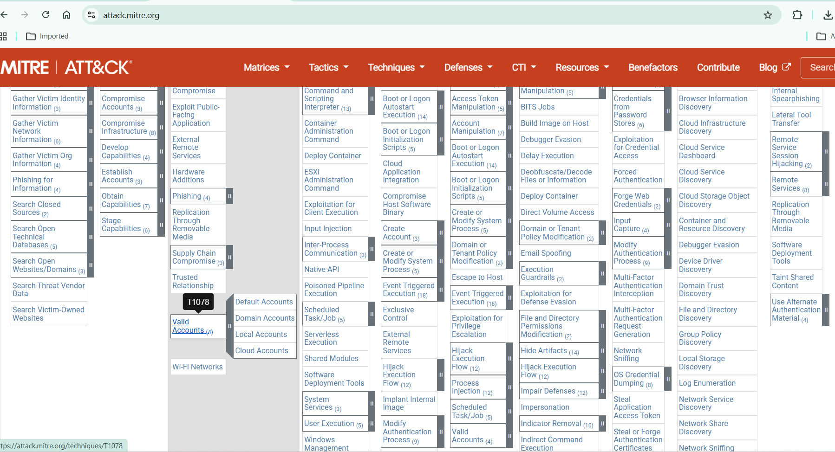
- Execution
T1059 – Command and Scripting Interpreter
Uploading DLL by PowerShell
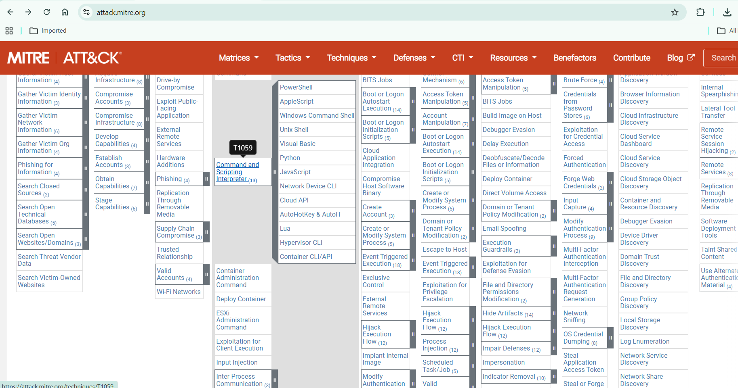
T1106 – Native API
Using windows API
RpcAddPrinterDriverEx
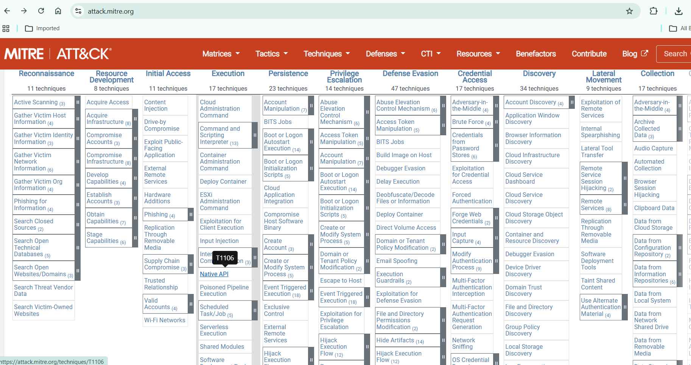
- Privilege escalation
T1068 – Exploitation for Privilege Escalation
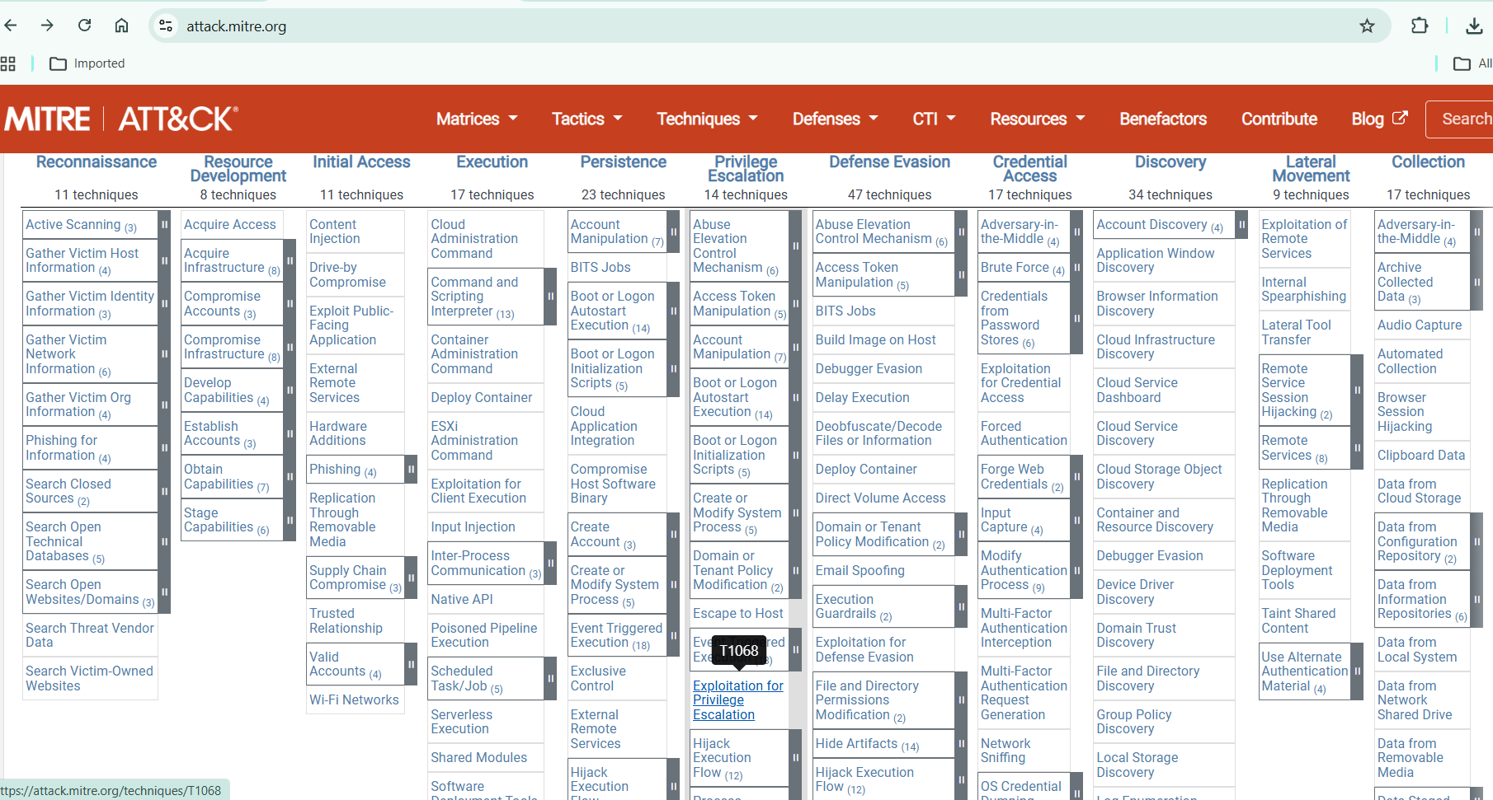
- Persistence
T1547 – Boot or Logon AutoStart Execution
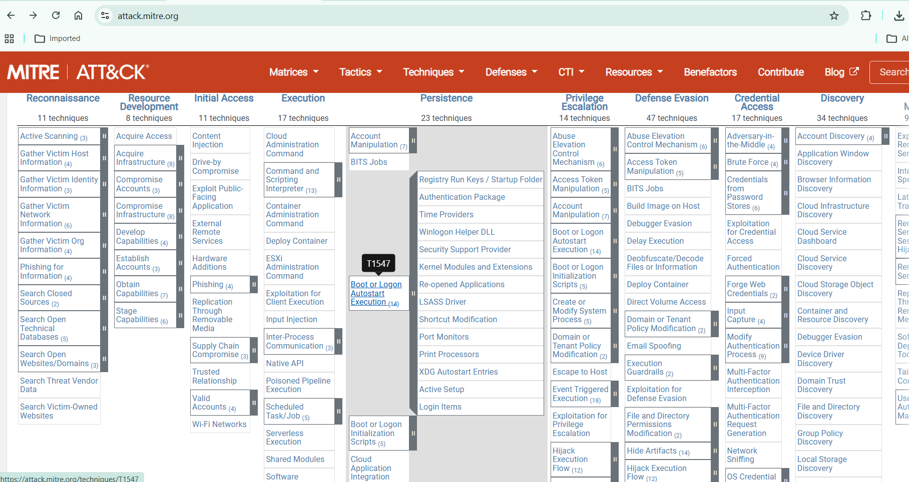
T1543.003 – Create or Modify System Process (Windows Service)
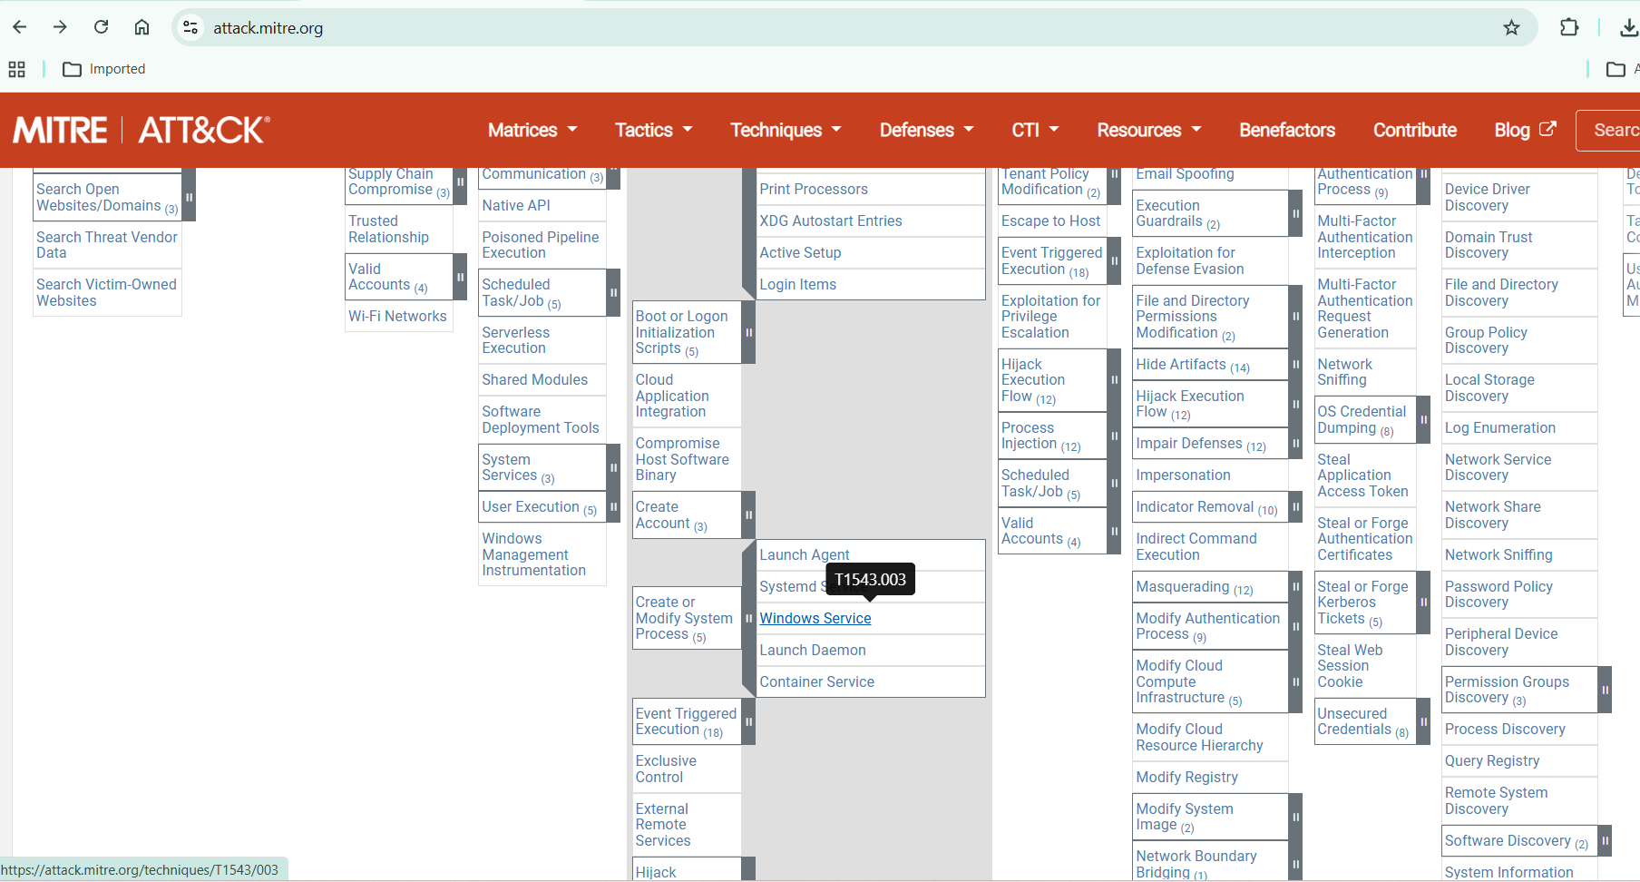
- Defense evasion
T1218 – Signed Binary Proxy Execution
spoolsv.exe
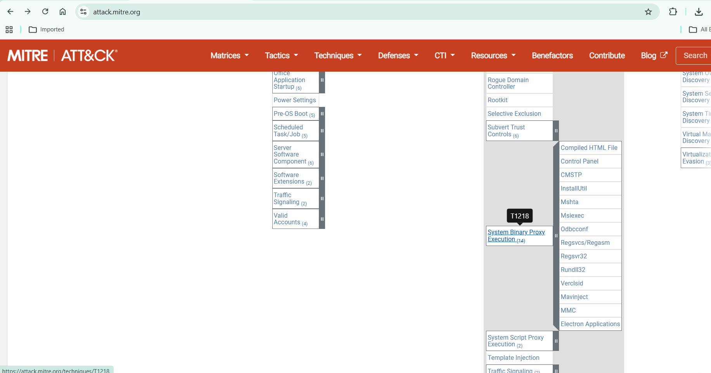
T1036 – Masquerading
DLL as printer name
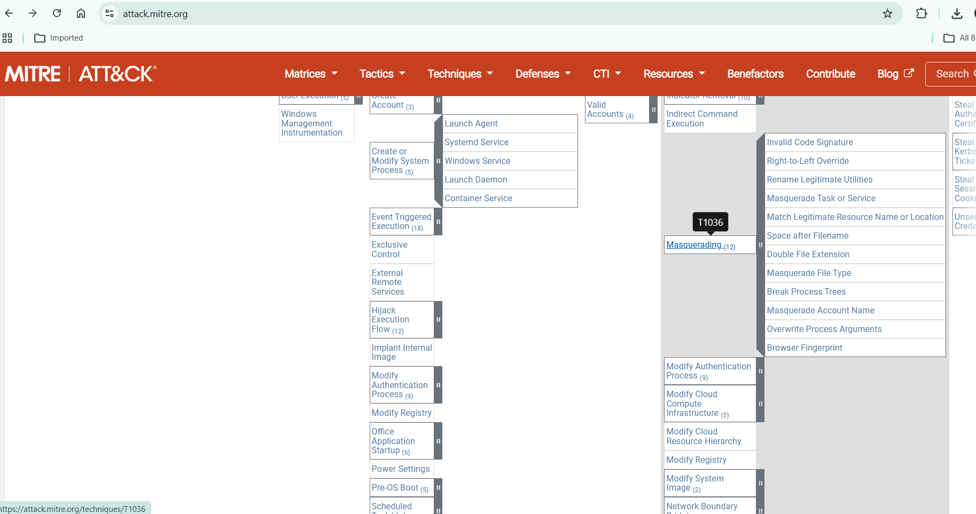
- Lateral movment
T1021 – Remote Services
Reach more devices by RPC/SMB
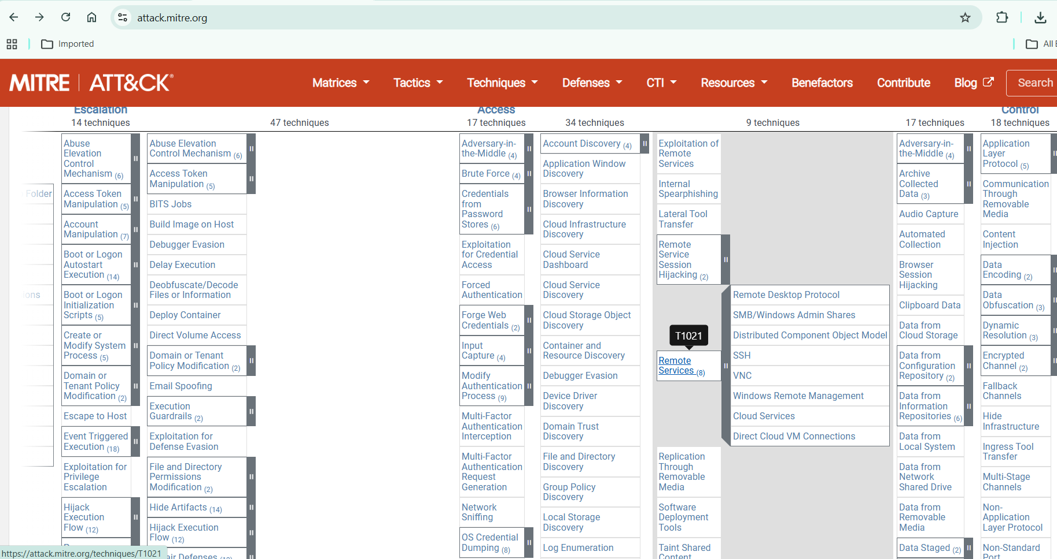
T1570 – Lateral Tool Transfer
Uploading DLL by SMB
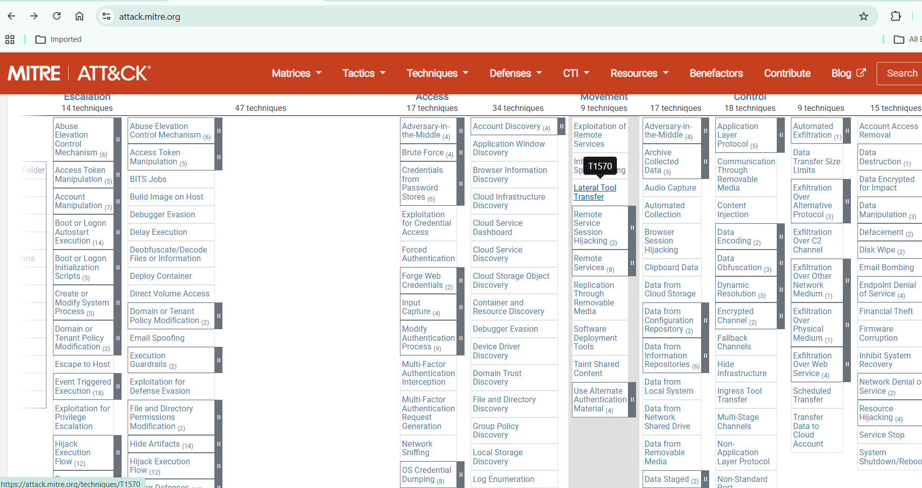
- Impact
T1484 – Domain Policy Modification
Control domain controller

